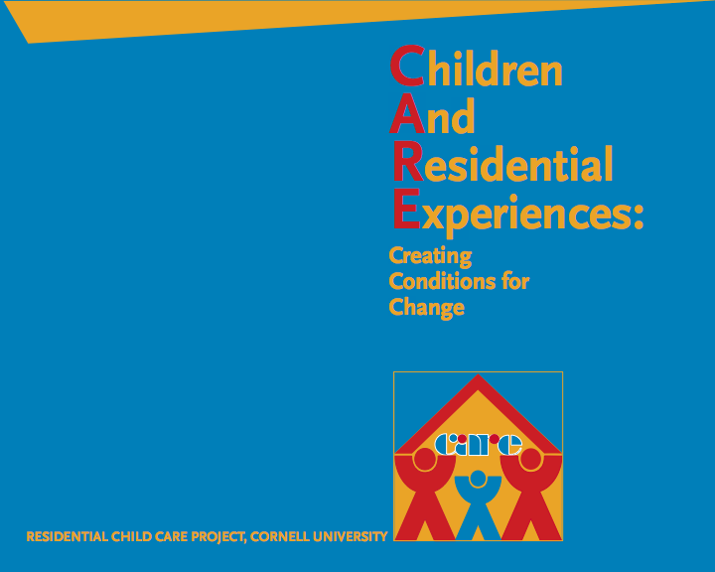

Materials for CARE Training Quantity Total $

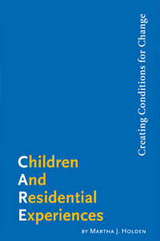CARE Book* - $22.00 each………………............... _________ ________

Total Ordered: _________ ________

Shipping Instructions:

Name _____________________________________________________________________________________________

Agency:______ _____________________________________________________________________________________

Address(no p.o. boxes):__________________________________________________________________________

Phone:___________________ Date needed by:____/____/____10(Please allow 2-3 weeks for shipping)

Mo./day/year

**Please return completed form and check or money order (payable to Cornell University) to:**

Trudy Radcliffe; Cornell University - RCCP; 37 Forest Home Dr. Rm. 3M402; Ithaca, NY 14853

**Orders will not be processed without check or money order.**

**CARE Books may also be ordered directly from the publisher: <http://www.cwla.org/pubs/>

CARE – Materials Order Form